USA 2020 BOA Travelling Fellowship – Zimmer Biomet Reconstructive Award: Nick Smith

Executive Summary

I was awarded £1500 to visit centres of excellence in sports and reconstructive knee surgery in the USA. The first place was Rush Medical Center in Chicago Illinois, observing Dr Brian Cole for a week. I observed him operate on two days as well as in clinic. Highlights included observing 3 osteochondral allografts transplantations, multiple ACL reconstructions and osteotomies. I was also able to go to a Chicago Bulls basketball match with Dr Cole as the team doctor for the evening.

The second half of the trip involved visiting Dr Robert LaPrade at the Twin Cities Orthopaedics Center in Minnesota. Dr LaPrade has arguably published more and helped progress the specialty of reconstructive knee surgery more than any other surgeon of his generation. It was a privilege to observe some his named procedures first hand. The majority of his cases were revisions, referred from other states and around the world. His diagnostic skill was excellent and use of stress radiographs, which is not done in most centres in the UK, was vital to his practice. His knowledge of anatomy was excellent and this helped in performing complex cases efficiently.

Overall, I feel very lucky to have been able to observe both institutions. I learnt a lot clinically, surgically but most of all, how to set up and joint clinical and academic practice to really advance your own skills and those of others. I have also made good contacts that I hope to use for future support and collaboration.

Travelling Fellowship Detail

My travelling fellowship was designed with the aim of seeing a different healthcare system, learning new surgical techniques (particularly complex and transplant procedures) and gaining an insight into how to develop a strong academic set up. Both surgeons I visited are world renowned for reconstructive soft tissue knee surgery, academically and surgically. Dr Cole has specific expertise in cartilage and transplant procedures, whilst Dr LaPrade is world renowned for ligament reconstruction procedures and a prolific research output.

I first visited Rush Medical Center in Chicago Illinois, observing Dr Brian Cole for a week. I observed him operate on two days, each with 10 – 11 patients between 2 theatres. His physician assistants and resident + fellow would set up and finish the cases, and Dr Cole would perform the surgery. Highlights included observing 3 osteochondral allografts (OCA) transplantations, multiple ACL reconstructions and osteotomies. Dr Cole is one of very few surgeons worldwide that has performed a high number of OCA. I have been part of a team that has published on the cost effectiveness of OCA, finding that it is highly effective and cost effective. I intend to perform this operation and this experience has particularly helped my understanding, given that experience in the UK is limited.

In order to run two theatres side by side, there needed to be great communication between the team and also with theatre staff, so although there were a lot of cases happening, it didn’t feel rushed. This kind of set up in not something I have seen in the UK, but there were certainly efficiencies that I observed, which could be implemented in the UK.

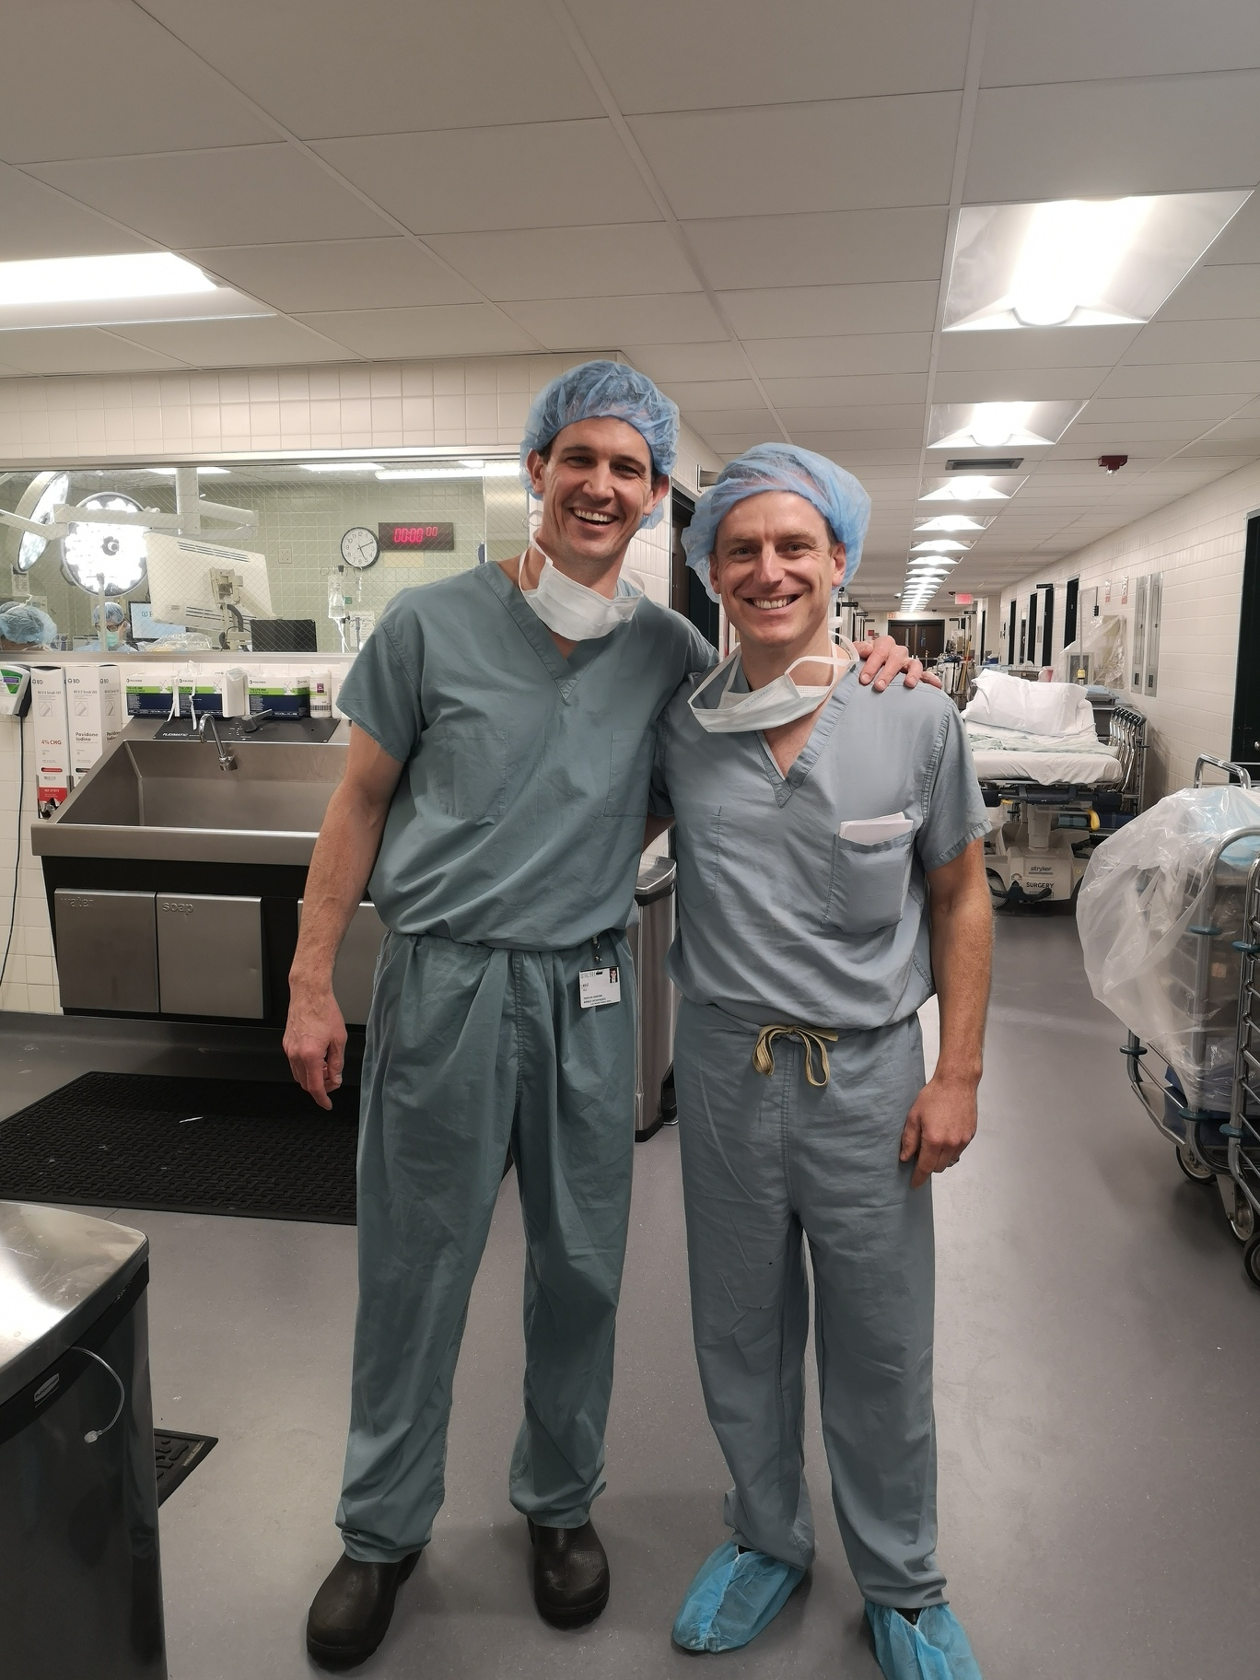
Photo 1: Myself with Kyle, Dr Cole’s Physician Assistant

On clinic days, there were a large number of patients, ranging from workers’ compensation cases to elite sports people with coaches present. During the time I was there, two Chicago Bulls players were injured and managed by Dr Cole. The coach and press were on the phone numerous times, wanting updates. I was also able to go to a Chicago Bulls Basketball match with Dr Cole as the team doctor for the evening (photo 2).

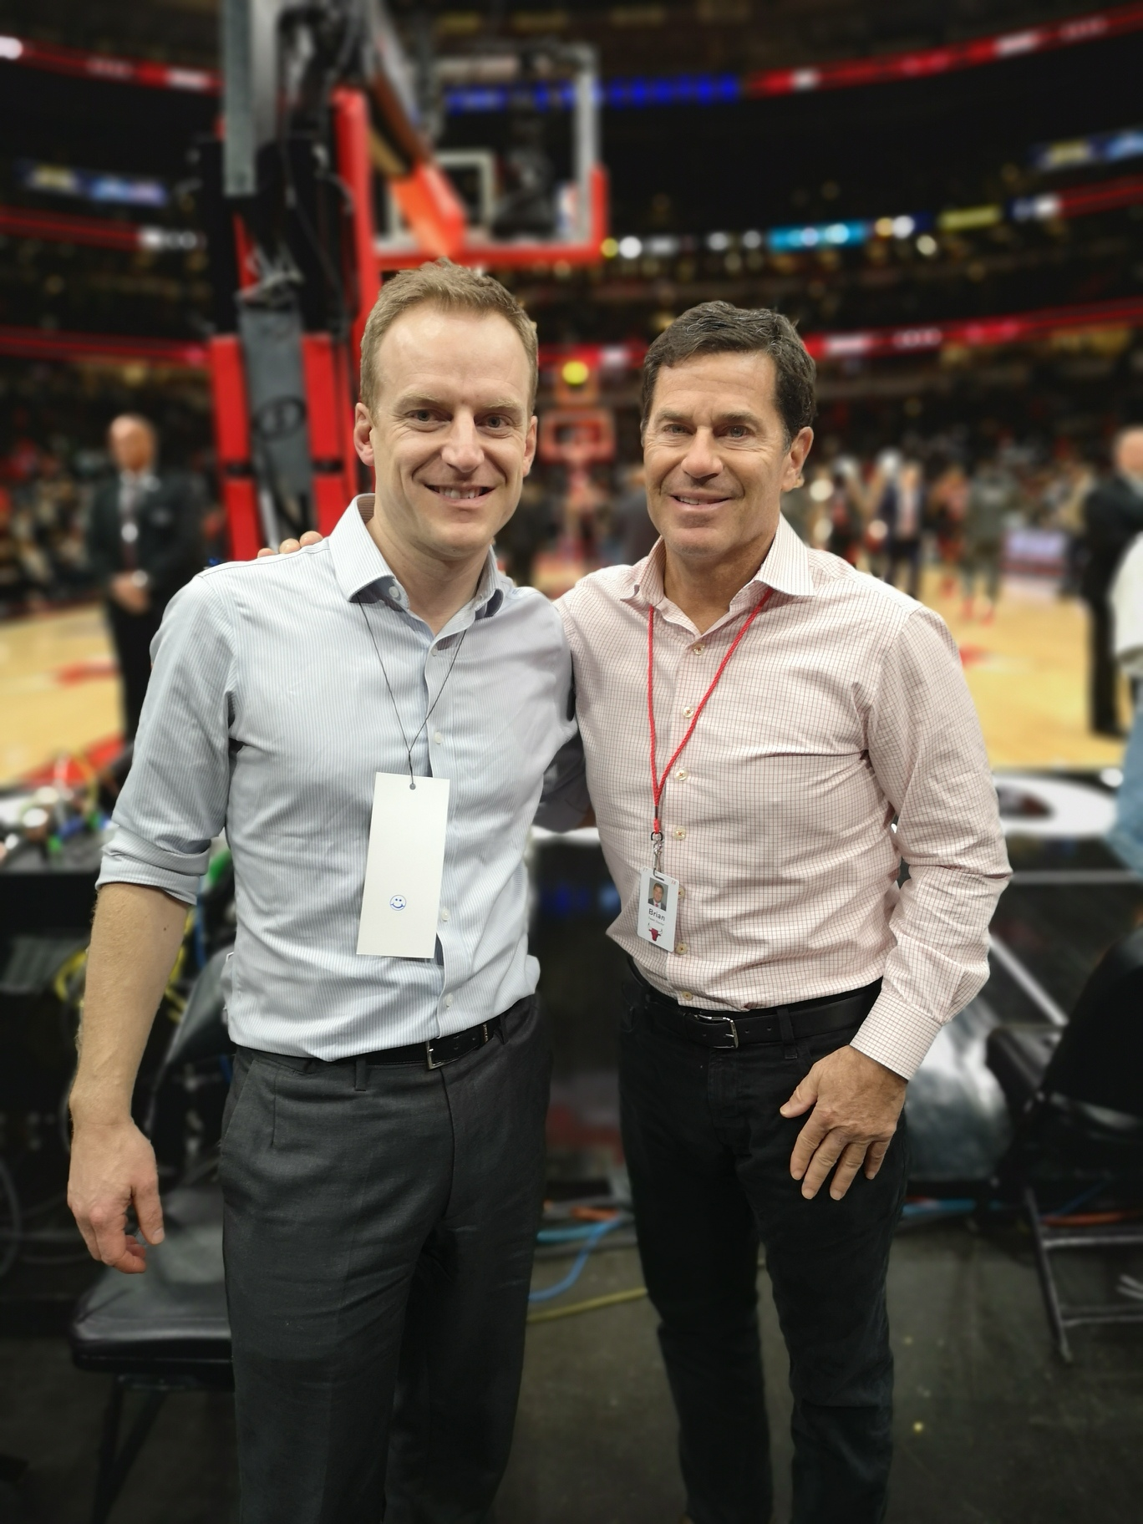
Photo 2: Myself with Dr Cole at the United Centre

The second half of the trip involved visiting Dr Robert LaPrade at the Twin Cities Orthopaedics Center in Minnesota. Dr LaPrade has arguably published more and helped progress the specialty of reconstructive knee surgery more than any other surgeon of his generation. Particular areas of expertise include the posterolateral corner and multiligament reconstructions. He has also published a lot of work on meniscal repairs, including for ramp lesions. I had the opportunity to talk about how to set up research and also how to consider a clinical topic for studying. Dr LaPrade has a very methodical approach, involving first understanding the anatomy and injury, with detailed anatomical and dissection studies. Once this is done, he would then focus on the surgical solution and test different variations, comparing to the current gold standard. Once the best solution has been found, this is tested clinically, with objective and patient reported outcomes used. I was able to discuss areas of future research interest and how I might test my ideas.

It was a privilege to observe some his named procedures first hand. I was able to see a multiligament reconstruction, meniscal ramp repair as well as osteochondral allograft and multiple revision procedures. The majority of his cases were revisions, referred from other states and around the world. Some cases had been poorly managed elsewhere, whilst others were not. In these cases Dr LaPrade, was methodical in trying to understand why the earlier procedures may have failed and what needs to be done differently.

In clinic, his diagnostic skill was excellent and use of stress radiographs, which is not done in most centres in the UK, was vital to his practice. Examples of this were varus stress radiographs on a 17 year old patient that presented with a failed ACL reconstruction. When he did stress radiograph, it showed a side to side difference of 2.9mm, indicating (from his previous work, and those of others) a LCL injury. In addition, on the MRI scan a lateral meniscal root tear was seen. Dr LaPrade also used stress radiographs for all possible PCL injuries and postoperatively. I have not seen this done in the UK, but was able to see their low budget set up, which would be easy to implement in the UK (photo 3).

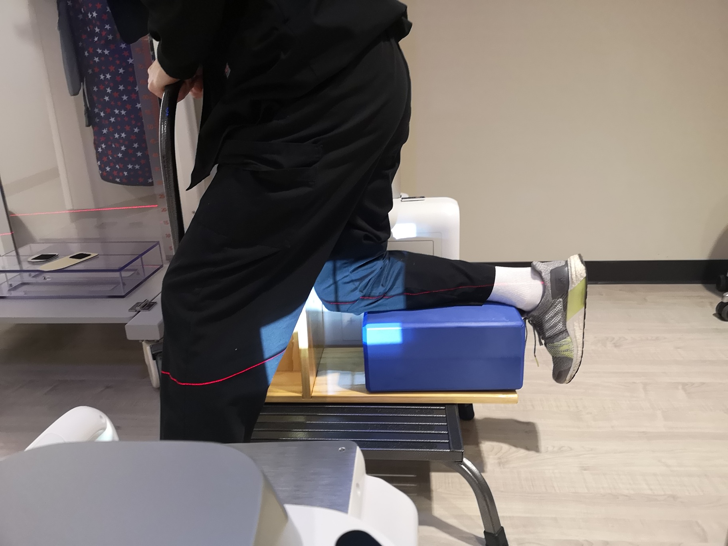
Photo 3: Demonstration of how to take PCL stress radiographs

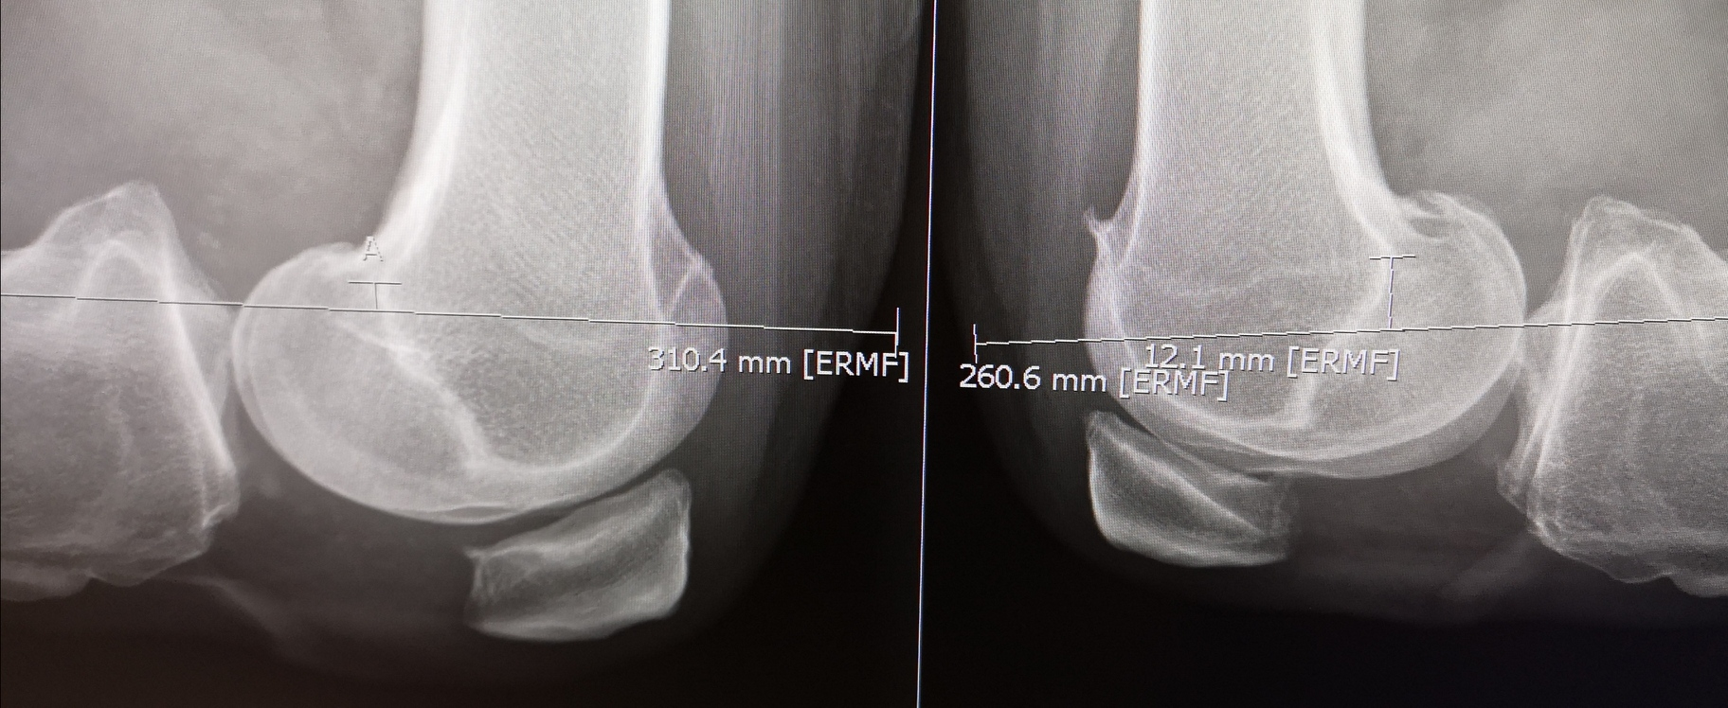
Photo 4: Example of a PCL injury, with a side to side comparison

Overall, I feel very lucky to have been able to observe both institutions. In terms of approach there were some marked differences, with positives and negatives around each. I think that I will be able to bring some of the best parts of each set up back into my future practice. This applies to the research side, the clinical side and also the patient and team member interactions. I have written up details of all the cases I observed to remind myself of certain procedures, and I intend to build on this new knowledge with literature reviews. I would like to thank the BOA and Zimmer Biomet for this fantastic opportunity. I would thoroughly recommend others in a similar position to try and do something similar.

