Travelling Fellowship Children’s Surgical Centre,
Phnomn Penh Cambodia,
Chatterjee Fellowship.

My name is Sara Dorman I am an ST7 from Mersey Deanery and from very early stage in my career it has always been my intention to become a paediatric orthopaedic surgeon. I am married to another orthopaedic registrar and we have a 3 year old son. Both my husband and I had undertaken short stints of overseas work in the past and it had long been our intention to undertake a longer placement we had enough clinical and surgical experience to offer valuable input. It is important in placement such as these not just to take away valuable clinical experience but add to the knowledge and skills base of the local surgeons.

The last year has been an eventful year for our family with both my husband and I sitting and passing the FRCS at the same time (despite all our friends, family and colleagues thinking we were mad), securing two international fellowships, battling family illness as my father passed away from prostate cancer just before Christmas, my mother in law is currently on chemotherapy for cholangiocarcinoma and we relocated our family temporarily to Cambodia. At times we wondered whether this was a sensible decision given our circumstances but I can honestly say it is the best decision we ever made, both from a career and personal point of view and we are hugely indebted to the BOA for their assistance in making this possible.

I have spent the last 6 months at the children’s surgical centre in Cambodia. During my time here I have undertaken both a clinical and training role. The Cambodian training system is very different to UK and the exposure to paediatric orthopaedics is variable. The local surgeons have a wealth of experience in limb deformity, non-union, neglected and iatrogenic injuries but very little experience in the management of elective paediatric problems such as cerebral palsy, DDH and syndromic children with limb deformities. Many of these conditions are diagnosed late and often only conservative management is offered leading to high rates of morbidity in the adolescent and young adult population.

The CSC is one of the only institutions in Cambodia currently offering hip replacement and to date have undertaken 256 total hips, of which around 25% were performed for untreated childhood hip dysplasia. Due to limited resources the hip replacements available are often manufactured with original polyethylene and have a very short lifespan in a young highly active population, with many wearing out after only a few years due to cheap but poor quality implants.

A strategy to allow early diagnosis and treatment of paediatric musculoskeletal problems is essential to reducing the burden of morbidity and disability in Cambodia. For this reason during the 6 months at CSC I focused on trying to improve the knowledge, assessment and principles of management of common paediatric orthopaedic problems with particular focus on screening and treatment for DDH.

Teaching sessions were undertaken to allow training of local staff in clinical screening for DDH, principles of practical management for late presenting DDH and training in more advanced surgical procedures for paediatric surgeons including femoral and pelvic osteotomies.

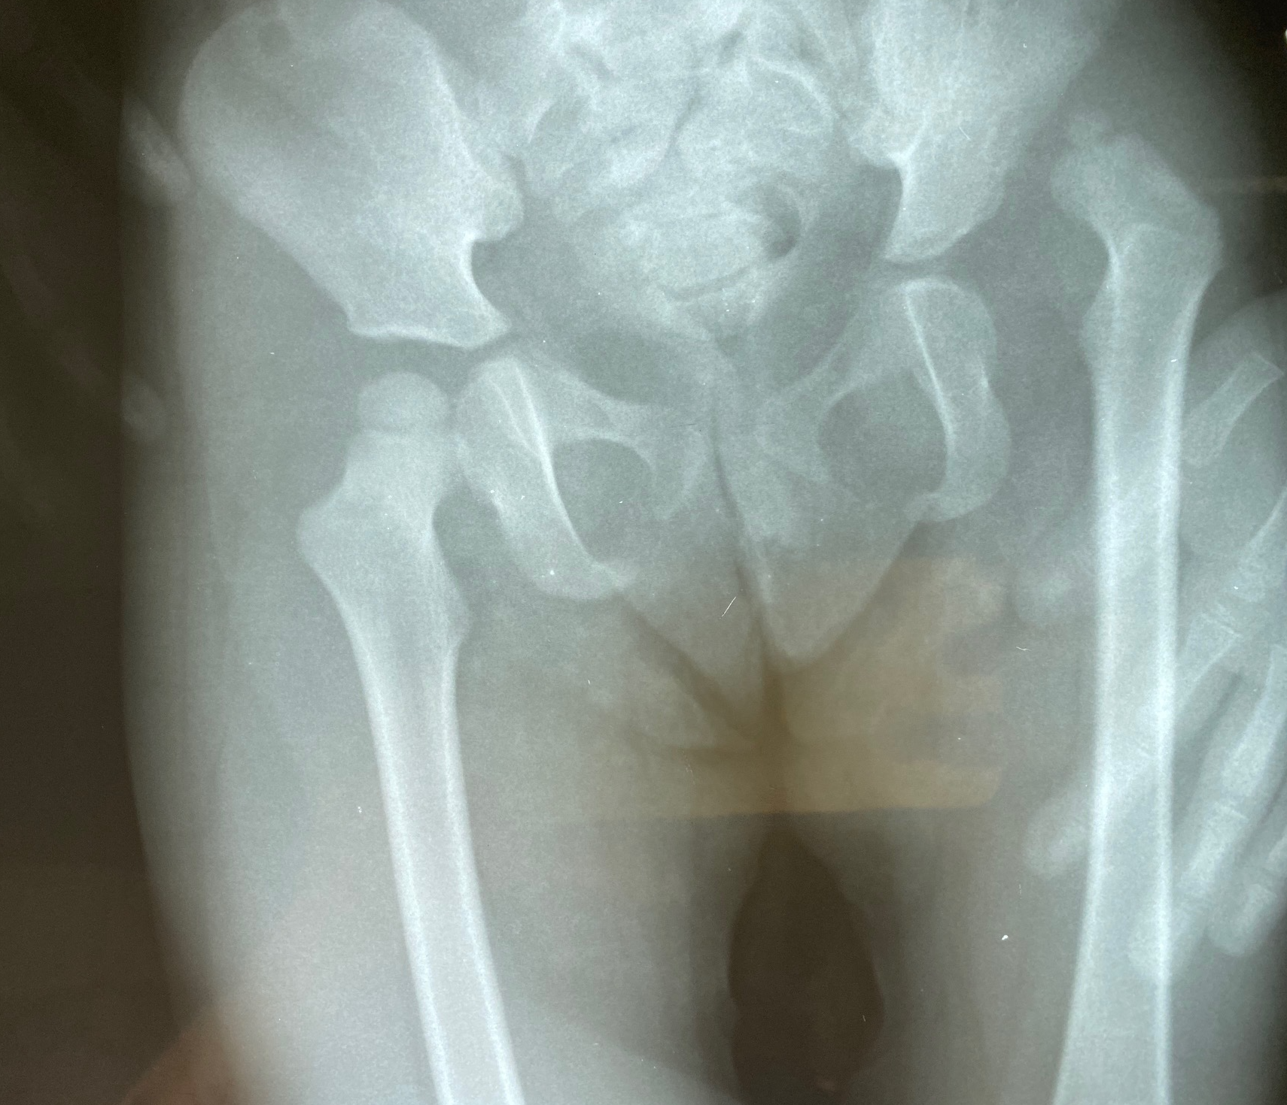
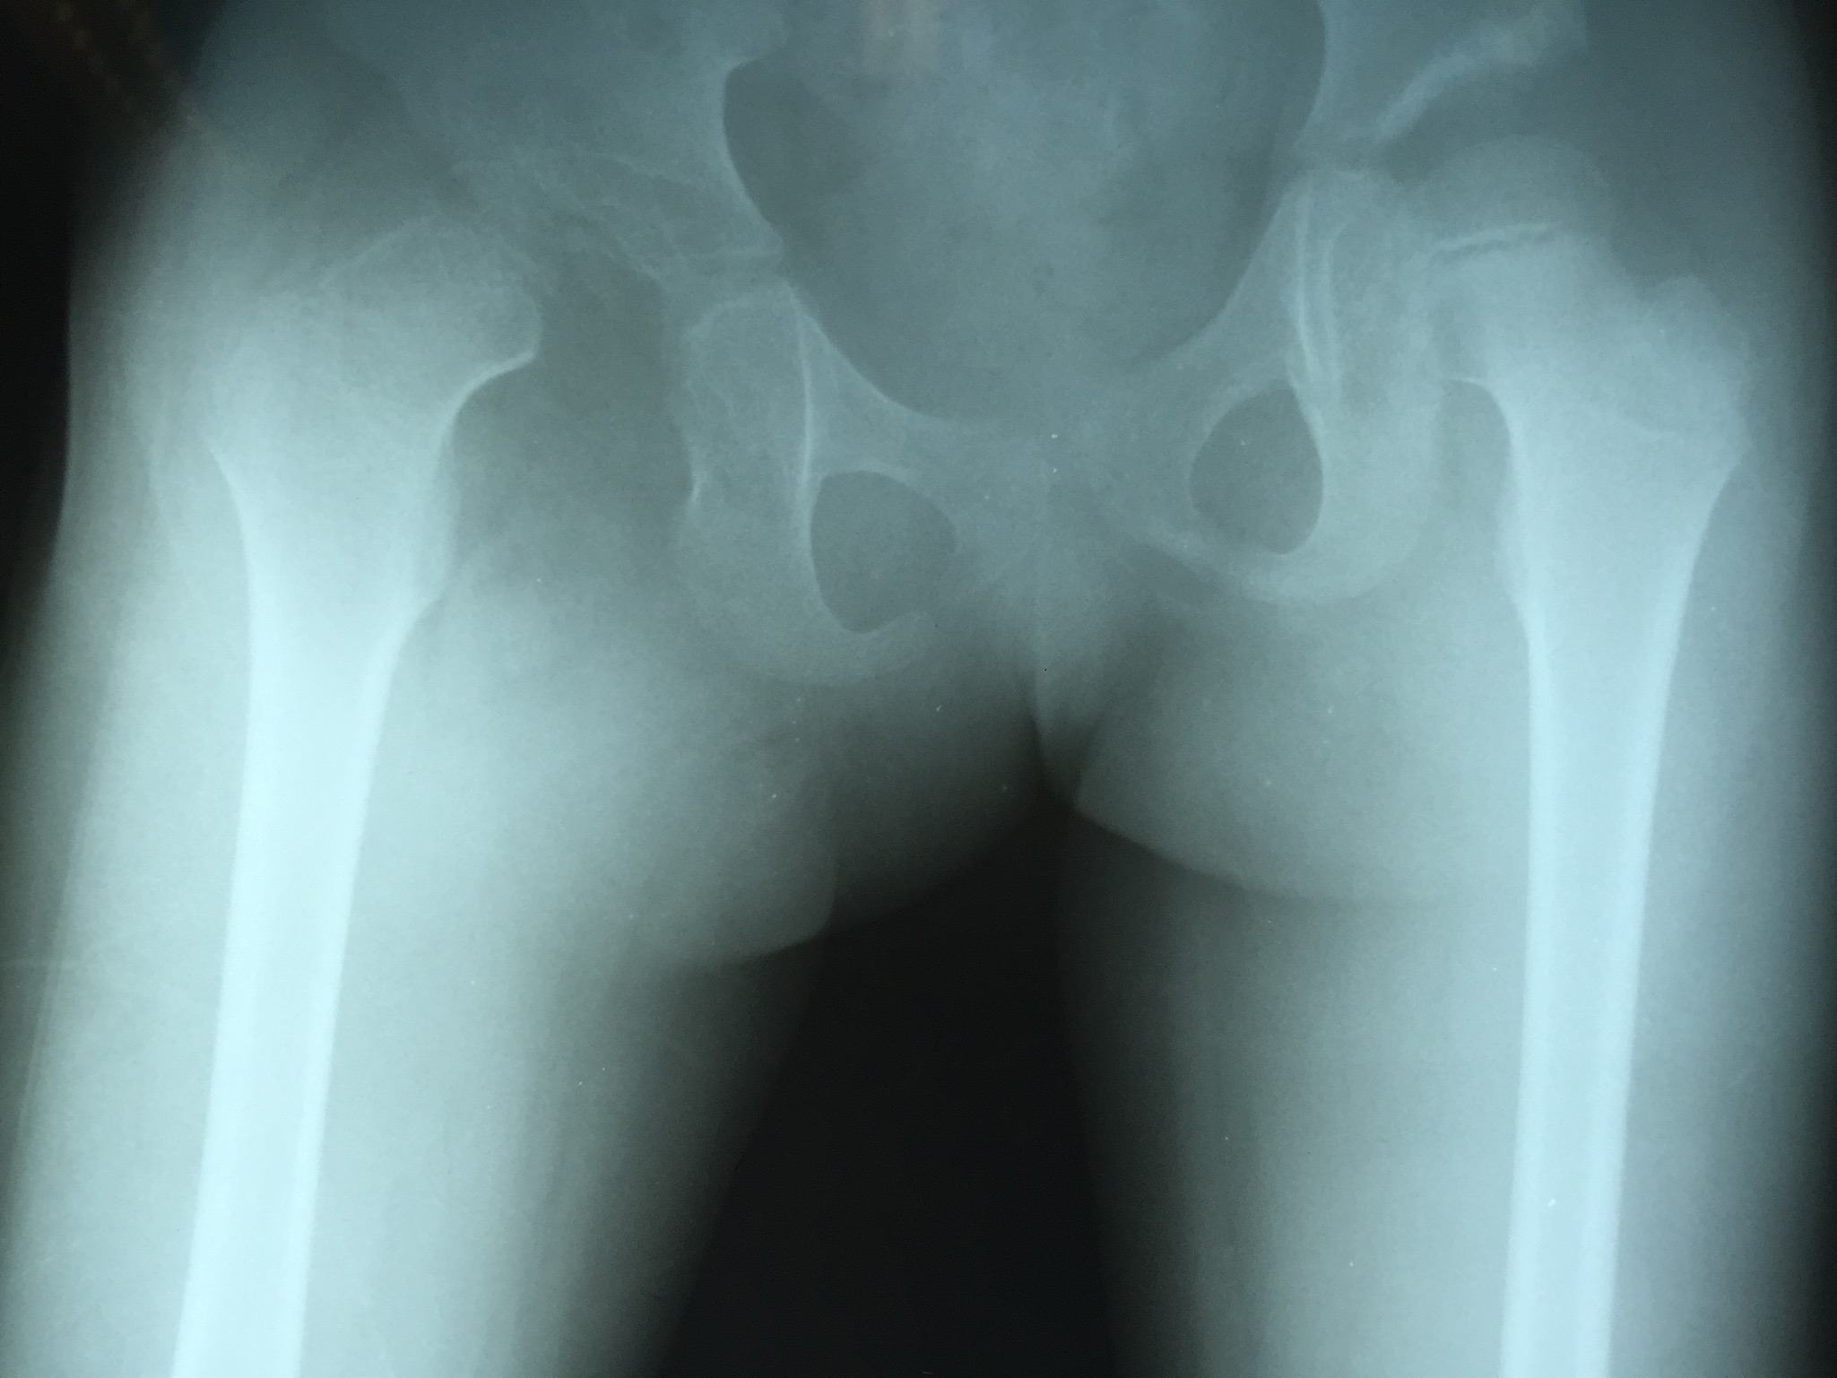
Figure 1: Typical late presenting DDH.

I also arranged an ultrasound workshop with a UK sonographer of 40 years experience to teach the local surgeons how to use ultrasound to scan for joint effusions and for diagnosis of DDH in young children to permit early non-invasive treatment and assess early response to pavliks harness.

In addition to the work on DDH the orthopaedic curriculum highlighted other under recognised conditions such as congenital vertical talus and congenital pseudoarthrosis of the tibia - last month we did the first periosteal grafting and Paley X type procedure in Cambodia.

Regular teaching sessions were successfully implemented for a paediatric orthopaedic curriculum, a research and ethics curriculum and an AO style practical course in basic fracture management for the rotating residents. It is anticipated that the curriculum will continue to roll on a 6 monthly basis under the supervision of local senior Khmer surgeons using the digital resources and equipment supplied to the hospital.

Spending time at the CSC has also been a hugely rewarding experience for me during which, I learnt a lot about myself as a surgeon and as a teacher. I had the opportunity to experience first hand the transition from registrar into a more independent practice, supervising juniors, dealing with complications and providing second opinions on a large number of complex cases and undiagnosed syndromes with multiple deformities, often relying on clinical acumen due to lack of advanced imaging and gait lab technology. I would also like to thank Mr Fergal Monsell and the Bristol consultant body for their input in numerous case conferences where particularly challenging cases were discussed.

Cambodia’s main mode of transport is the motorbike and with a paying healthcare system and high levels of poverty many who come off their motorbikes seek traditional medicine or no care at all. The Khmer surgeons here see and successfully treat very high volumes of traumatic brachial plexus and peripheral nerve injuries. Equally obstetric and paediatric care is difficult to access and of variable quality resulting in a spectrum of cerebral palsy type cases either at birth or post meningitis. I have been able to expand my personal cross speciality experience in nerve injury and tendon transfer in brachial plexus injury, microsurgery, selective denervation for spasticity and congenital hand.
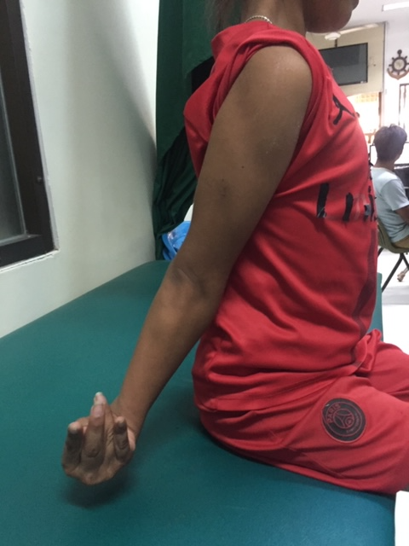
Figure 2: Hemiplegic cerebral palsy with right upper limb stuck in “erbs” type position with triceps, FCU and pronator teres spasticity.

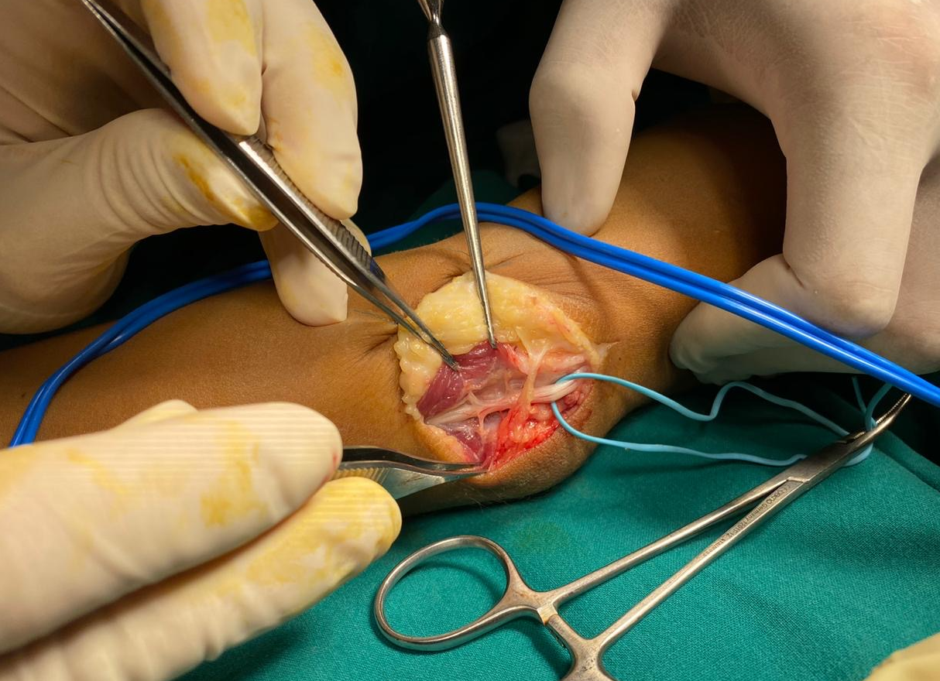

Figure 3: Selective denervation of FCU. Picture demonstrating ulnar nerve and branches to head of FCU.

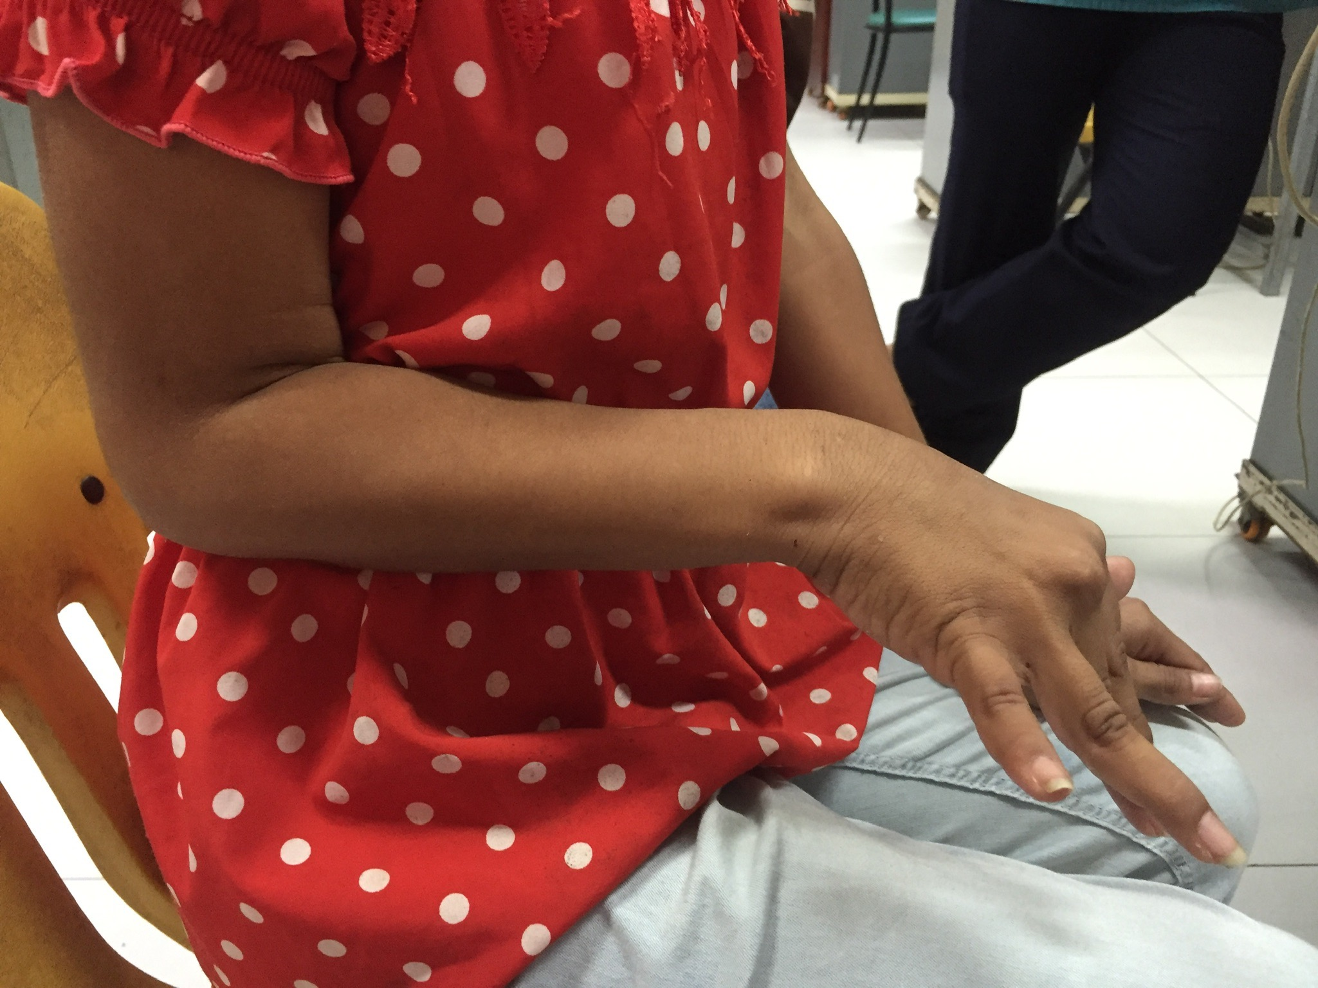
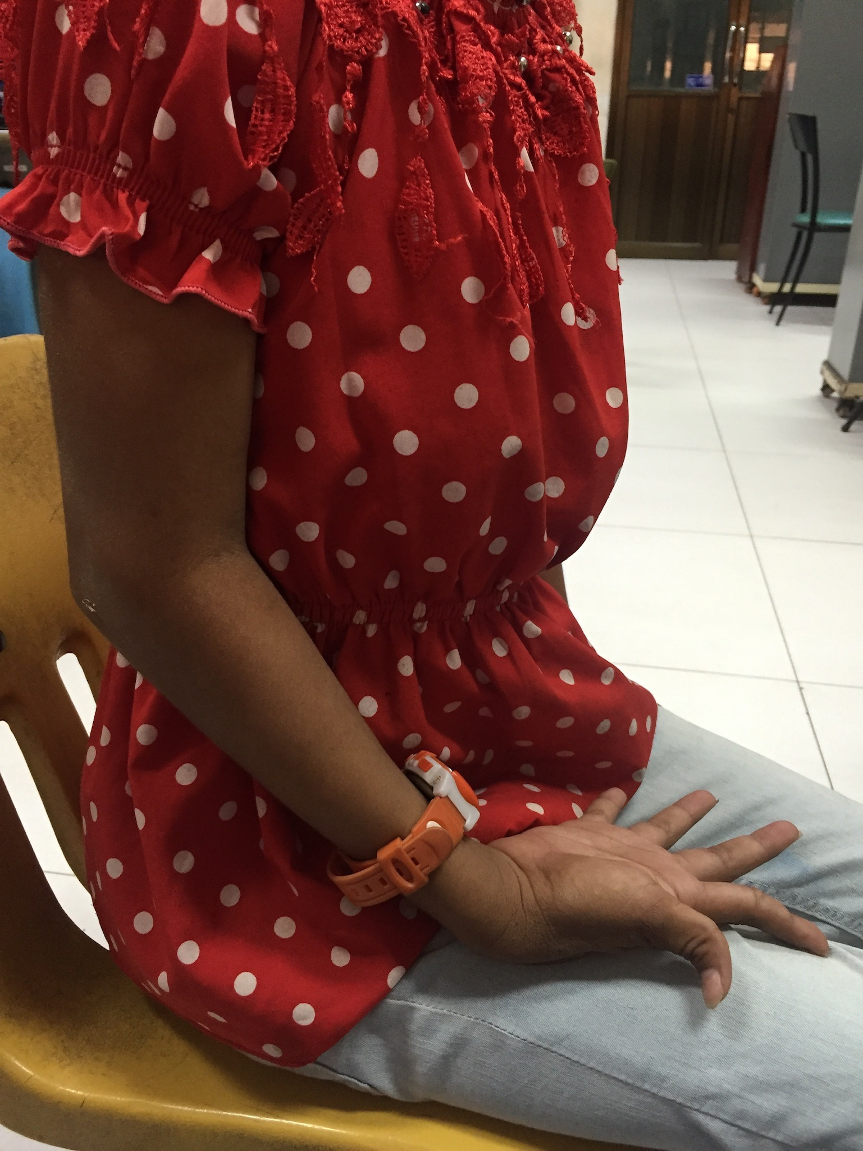

Figure 4: Post-operative selective denervation of triceps and FCU. Improved cosmesis and functioning as an assisting arm for bimanual tasks

This experience has been both life and career changing and I am extremely grateful to the BOA and the Chatterjee fellowship without which this fellowship simply wouldn’t have been possible. I would thoroughly encourage anyone considering overseas work to take a leap of faith - it will be a rewarding decision!

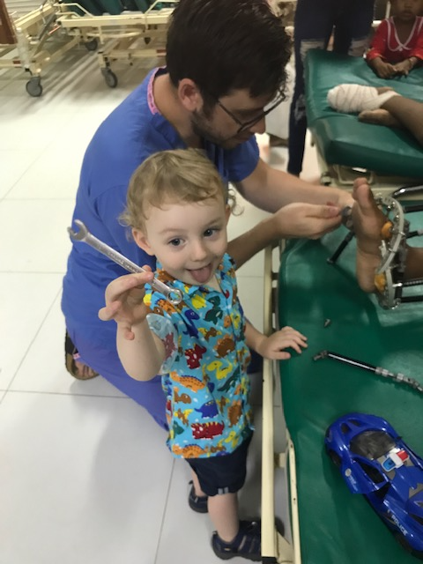
Figure 5 : Flexible work life balance. When your nanny is sick its no problem to bring a young apprentice to work for the day!

